**Web development project**

**Subject:-** making website using HTML5, CSS and JavaScript.

**HTML FILES**

PAGE 1:- File name home.html

CODE:-

|  |
| --- |
| **<!DOCTYPE html>**  **<html>**  **<head>**  **<link rel="stylesheet" href="stylesheet.css" />**  **<title>Application form</title>**  **</head>**  **<body style="background-color: rgb(189, 224, 255)">**  **<div class="div1">**  **<ul>**  **<li class="liClass">**  **<a href="home.html">Home</a>**  **</li>**  **<li class="liClass">**  **<a href="courses.html">Courses</a>**  **</li>**  **<li class="liClass">**  **<a href="about.html">About Us</a>**  **</li>**  **<li class="liClass">**  **<a href="application.html">Application form</a>**  **</li>**  **<li class="liClass">**  **<a href="contact.html">Contact Us</a>**  **</li>**  **</ul>**  **<div class="div2">**  **<center><h2>WELCOME TO APNA COMPUTER INSTITUTE</h2></center>**  **<hr />**  **<p>**  **Welcome to APNA COMPUTER INSTITUTE, a leading institute for computer**  **education and training. Our goal is to provide top-quality education**  **to students who want to advance their careers in the field of**  **computers.<br /><br />**  **We offer a wide range of courses that cater to the needs of different**  **students. Whether you're a beginner or an advanced user, we have**  **something for everyone. Our courses include basics of computer**  **operations, programming, web development, database management, graphic**  **design, and more.<br /><br />**  **Our faculty comprises of highly qualified and experienced instructors**  **who are experts in their respective fields. They use the latest**  **teaching methods and technologies to ensure that our students receive**  **the best education possible.<br /><br />**  **At [Name of Your Computer Institute], we believe in hands-on learning.**  **Our courses are designed to provide students with practical experience**  **in addition to theoretical knowledge. We have state-of-the-art labs**  **with the latest equipment and software to ensure that our students are**  **fully equipped to enter the workforce with confidence.<br /><br />**  **Our institute has a strong track record of success. Many of our**  **graduates have gone on to work for some of the top companies in the**  **industry, both in India and abroad. We take pride in the success of**  **our students, and we are committed to helping each and every one of**  **them achieve their goals.<br /><br />**  **Whether you're looking to start a new career in the field of computers**  **or advance your existing one, APNA COMPUTER INSTITUTE is the perfect**  **place for you. Contact us today to learn more about our courses and**  **how we can help you achieve your goals.**  **</p>**  **</div>**  **</div>**  **<script type="text/javascript" src="index.js"></script>**  **</body>**  **</html>** |

**OUTPUT SCREEN SHOT:-**

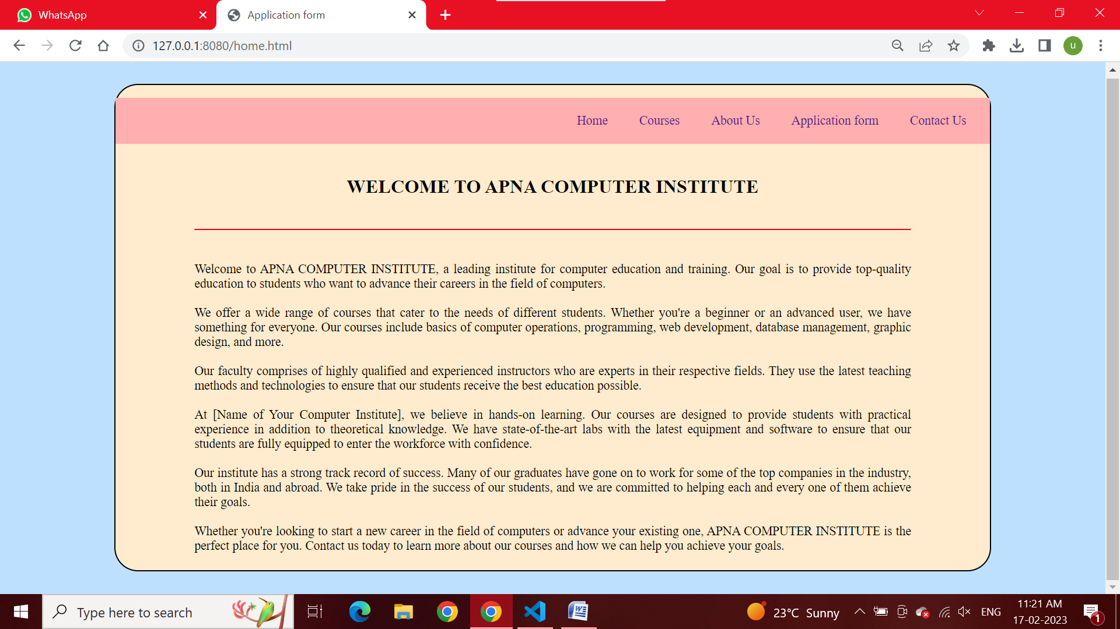

PAGE 2:- File name courses.html

CODE:-

|  |
| --- |
| **<!DOCTYPE html>**  **<html>**  **<head>**  **<link rel="stylesheet" href="stylesheet.css" />**  **<title>Application form</title>**  **</head>**  **<body style="background-color: rgb(189, 224, 255)">**  **<div class="div1">**  **<ul>**  **<li class="liClass">**  **<a href="home.html">Home</a>**  **</li>**  **<li class="liClass">**  **<a href="courses.html">Courses</a>**  **</li>**  **<li class="liClass">**  **<a href="about.html">About Us</a>**  **</li>**  **<li class="liClass">**  **<a href="application.html">Application form</a>**  **</li>**  **<li class="liClass">**  **<a href="contact.html">Contact Us</a>**  **</li>**  **</ul>**  **<div class="div2">**  **<h2>Courses which we provide</h2>**  **<hr />**  **<ol>**  **<li>O LEVEL</li>**  **<li>A LEVEL</li>**  **<li>ADCA</li>**  **<li>DCA</li>**  **<li>TALLY</li>**  **<li>CCC</li>**  **</ol>**  **</div>**  **</div>**  **<script type="text/javascript" src="index.js"></script>**  **</body>**  **</html>** |

**OUTPUT SCREEN SHOT:-**

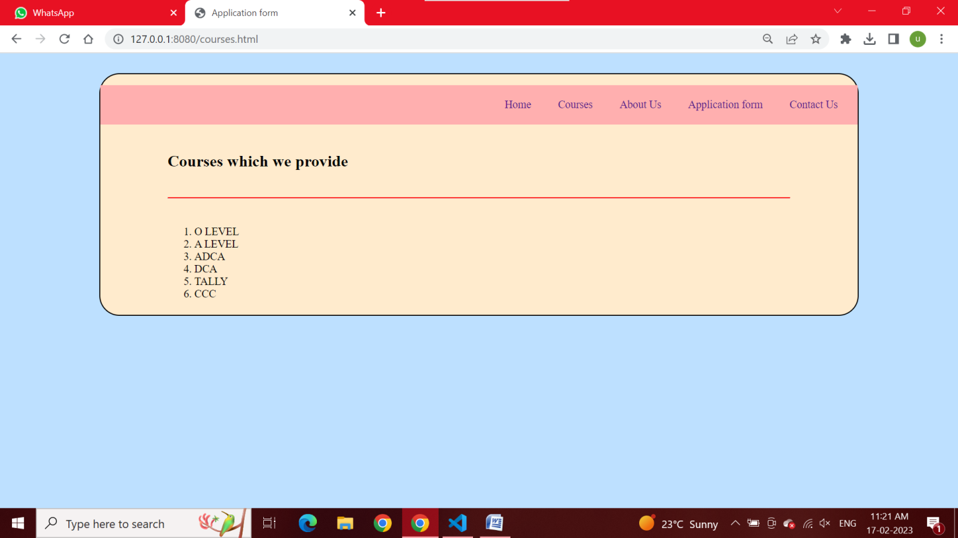

PAGE 3:- File name about.html

CODE:-

|  |
| --- |
| **<!DOCTYPE html>**  **<html>**  **<head>**  **<link rel="stylesheet" href="stylesheet.css" />**  **<title>Application form</title>**  **</head>**  **<body style="background-color: rgb(189, 224, 255)">**  **<div class="div1">**  **<ul>**  **<li class="liClass">**  **<a href="home.html">Home</a>**  **</li>**  **<li class="liClass">**  **<a href="courses.html">Courses</a>**  **</li>**  **<li class="liClass">**  **<a href="about.html">About Us</a>**  **</li>**  **<li class="liClass">**  **<a href="application.html">Application form</a>**  **</li>**  **<li class="liClass">**  **<a href="contact.html">Contact Us</a>**  **</li>**  **</ul>**  **<div class="div2">**  **<h2>About CBIIT</h2>**  **<p style="fone-size: 25px; text-align: justify">**  **Lorem Ipsum is simply dummy text of the printing and typesetting**  **industry. Lorem Ipsum has been the industry's standard dummy text ever**  **since the 1500s, when an unknown printer took a galley of type and**  **scrambled it to make a type specimen book. It has survived not only**  **five centuries, but also the leap into electronic typesetting,**  **remaining essentially unchanged.<br /><br />**  **The standard chunk of Lorem Ipsum used since the 1500s is reproduced**  **below for those interested. Sections 1.10.32 and 1.10.33 from "de**  **Finibus Bonorum et Malorum" by Cicero are also reproduced in their**  **exact original form, accompanied by English versions from the 1914**  **translation by H. Rackham.<br /><br />**  **It is a long established fact that a reader will be distracted by the**  **readable content of a page when looking at its layout. The point of**  **using Lorem Ipsum is that it has a more-or-less normal distribution of**  **letters, as opposed to using 'Content here, content here', making it**  **look like readable English. Many desktop publishing packages and web**  **page editors now use Lorem Ipsum as their default model text, and a**  **search for 'lorem ipsum' will uncover many web sites still in their**  **infancy.<br /><br />**  **</p>**  **</div>**  **</div>**  **<script type="text/javascript" src="index.js"></script>**  **</body>**  **</html>** |

**OUTPUT SCREEN SHOT:-**

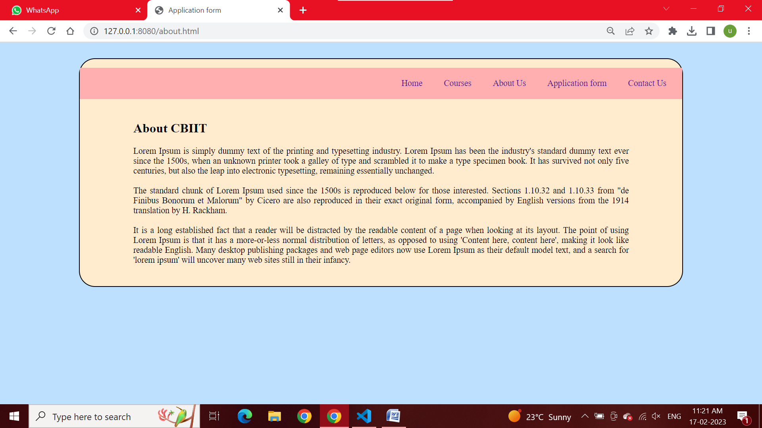

PAGE 4:- File name application.html

CODE:-

|  |
| --- |
| **<!DOCTYPE html>**  **<html>**  **<head>**  **<link rel="stylesheet" href="stylesheet.css" />**  **<title>Application form</title>**  **</head>**  **<body style="background-color: rgb(189, 224, 255)">**  **<div class="div1">**  **<ul>**  **<li class="liClass">**  **<a href="home.html">Home</a>**  **</li>**  **<li class="liClass">**  **<a href="courses.html">Courses</a>**  **</li>**  **<li class="liClass">**  **<a href="about.html">About Us</a>**  **</li>**  **<li class="liClass">**  **<a href="application.html">Application form</a>**  **</li>**  **<li class="liClass">**  **<a href="contact.html">Contact Us</a>**  **</li>**  **</ul>**  **<div class="div2">**  **<form onsubmit="onSubmitForm()">**  **<table>**  **<tr>**  **<td colspan="2">**  **<h1>**  **<center>Application form</center>**  **</h1>**  **<center>**  **<marquee width="80%" behavior="" direction="right"**  **>Please enter your application details</marquee**  **>**  **</center>**  **<hr />**  **</td>**  **</tr>**  **<tr>**  **<td><label>First name:</label></td>**  **<td><input type="text" required /></td>**  **</tr>**  **<tr>**  **<td><label>Middle name:</label></td>**  **<td><input type="text" required /></td>**  **</tr>**  **<tr>**  **<td><label>Last name:</label></td>**  **<td><input type="text" required /></td>**  **</tr>**  **<tr>**  **<td><label>Father's name:</label></td>**  **<td><input type="text" required /></td>**  **</tr>**  **<tr>**  **<td><label>Mother's name:</label></td>**  **<td><input type="text" required /></td>**  **</tr>**  **<tr>**  **<td><label>ID Number</label></td>**  **<td><input type="number" required /></td>**  **</tr>**  **<tr>**  **<td><label>Mobile number</label></td>**  **<td><input type="number" required /></td>**  **</tr>**  **<tr>**  **<td><label>E-mail</label></td>**  **<td><input type="email" required /></td>**  **</tr>**  **<tr>**  **<td><label>Address</label></td>**  **<td><input type="text" required /></td>**  **</tr>**  **<tr>**  **<td><label>Date of Birth</label></td>**  **<td><input type="date" required /></td>**  **</tr>**  **<tr>**  **<td><label>Gender</label></td>**  **<td>**  **male<input**  **style="width: auto; padding: 0px"**  **type="radio"**  **name="gender"**  **required**  **/>**  **Female<input**  **style="width: auto; padding: 0px"**  **type="radio"**  **name="gender"**  **required**  **/>Other<input**  **style="width: auto; padding: 0px"**  **type="radio"**  **name="gender"**  **required**  **/>**  **</td>**  **</tr>**  **<tr>**  **<td><label>Select course</label></td>**  **<td>**  **<select>**  **<option>O LEVEL</option>**  **<option>A LEVEL</option>**  **<option>CCC</option>**  **<option>DCA</option>**  **<option>ADCA</option>**  **<option>TALLY</option>**  **</select>**  **</td>**  **</tr>**  **<tr>**  **<td></td>**  **<td colspan="2">**  **<input**  **style="width: 80px"**  **type="submit"**  **value="submit"**  **required**  **/>**  **</td>**  **</tr>**  **</table>**  **</form>**  **</div>**  **</div>**  **<script type="text/javascript" src="index.js"></script>**  **</body>**  **</html>** |

**OUTPUT SCREEN SHOT:-**

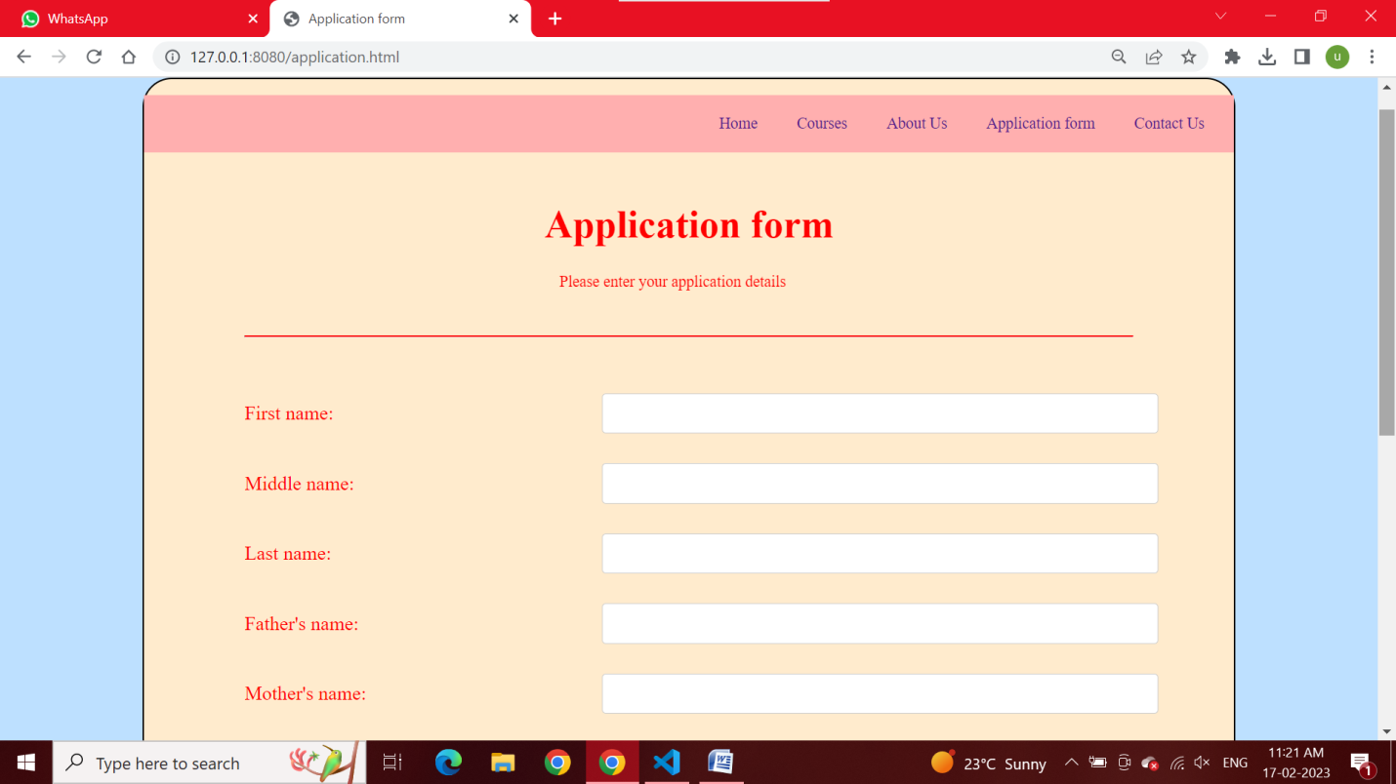

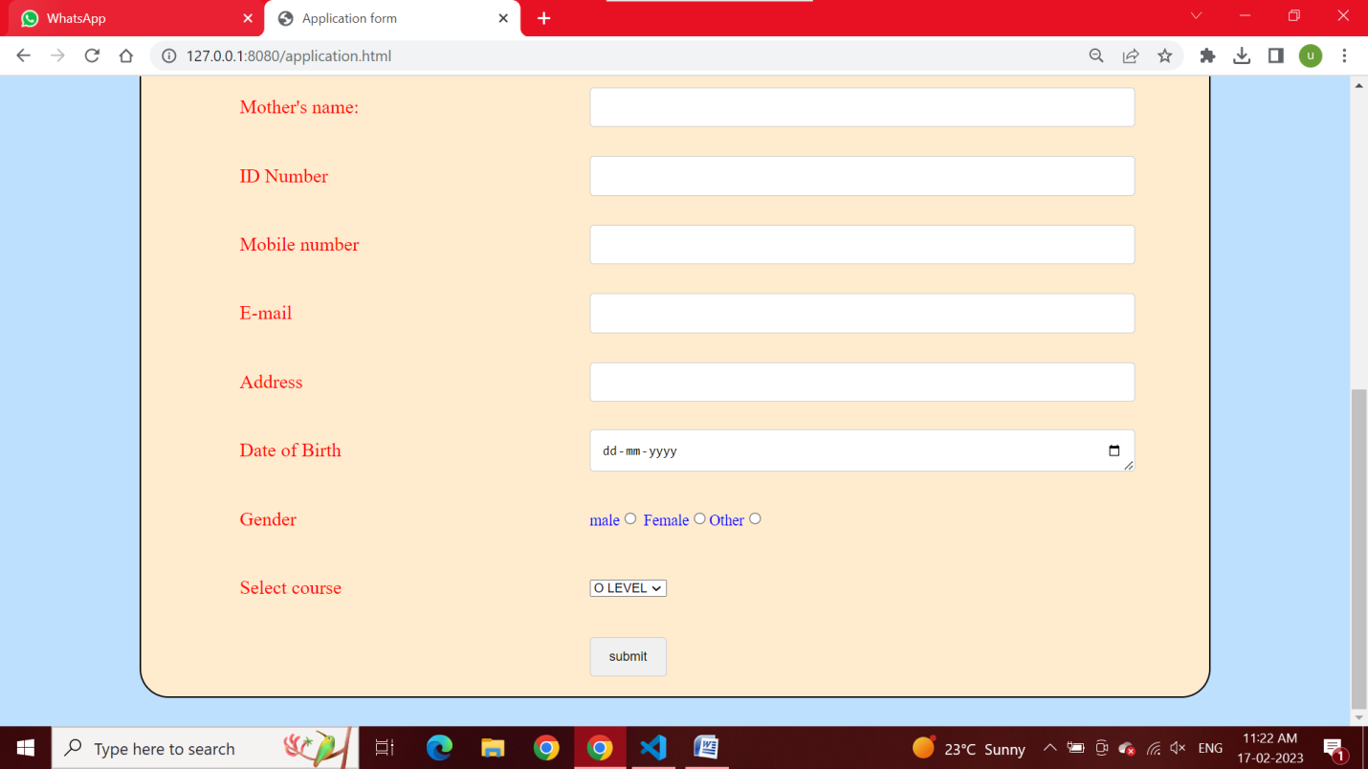

PAGE 5:- File name application.html

CODE:-

|  |
| --- |
| **<!DOCTYPE html>**  **<html>**  **<head>**  **<link rel="stylesheet" href="stylesheet.css" />**  **<title>Application form</title>**  **</head>**  **<body style="background-color: rgb(189, 224, 255)">**  **<div class="div1">**  **<ul>**  **<li class="liClass">**  **<a href="home.html">Home</a>**  **</li>**  **<li class="liClass">**  **<a href="courses.html">Courses</a>**  **</li>**  **<li class="liClass">**  **<a href="about.html">About Us</a>**  **</li>**  **<li class="liClass">**  **<a href="application.html">Application form</a>**  **</li>**  **<li class="liClass">**  **<a href="contact.html">Contact Us</a>**  **</li>**  **</ul>**  **<div class="div2">**  **<h2>Contact details</h2>**  **<p>**  **Email: abc@gmail.com <br />**  **contact number: +91987635242 <br />**  **address: sector 10 C, vrindavan yojna, Lucknow**  **</p>**  **<form onsubmit="onSubmitForm()">**  **<table>**  **<tr>**  **<td colspan="2">**  **<h1>**  **<center>Raise your query</center>**  **</h1>**  **<hr />**  **</td>**  **</tr>**  **<tr>**  **<td><label>Your name:</label></td>**  **<td><input type="text" required /></td>**  **</tr>**  **<tr>**  **<td><label>Mobile number</label></td>**  **<td><input type="number" required /></td>**  **</tr>**  **<tr>**  **<td><label>E-mail</label></td>**  **<td><input type="email" required /></td>**  **</tr>**  **<tr>**  **<td><label>Your query</label></td>**  **<td>**  **<textarea**  **id="subject"**  **name="subject"**  **placeholder="Write something.."**  **style="height: 200px"**  **></textarea>**  **</td>**  **</tr>**  **<tr>**  **<td></td>**  **<td colspan="2">**  **<input**  **style="width: 80px"**  **type="submit"**  **value="submit"**  **required**  **/>**  **</td>**  **</tr>**  **</table>**  **</form>**  **</div>**  **</div>**  **<script type="text/javascript" src="index.js"></script>**  **</body>**  **</html>** |

**OUTPUT SCREEN SHOT:-**

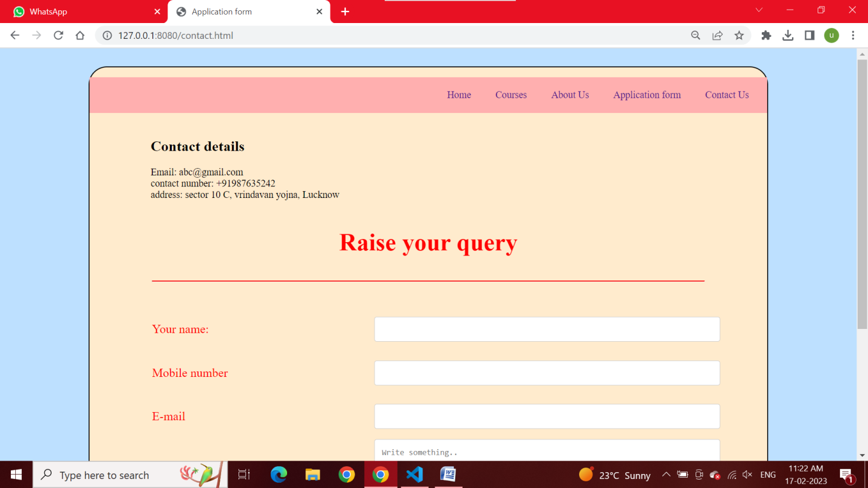

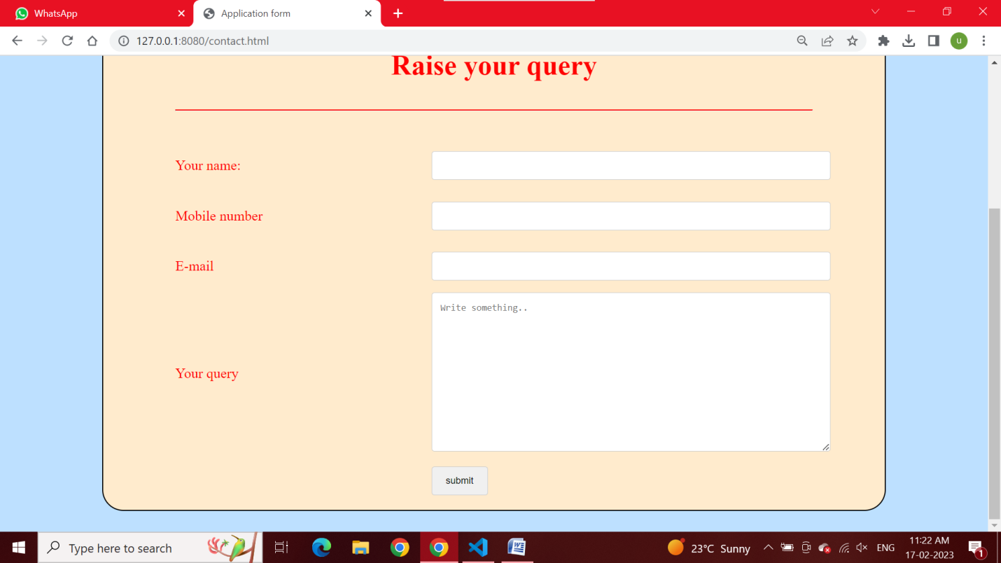

**CSS FILE**

**File Name : - stylesheet.css**

|  |
| --- |
| **/* elements */**  **table {**  **width: 100%;**  **}**  **h1 {**  **color: red;**  **align-items: center;**  **}**  **marquee {**  **font-size: 16px;**  **}**  **input {**  **width: 100%;**  **padding: 12px;**  **border: 1px solid #ccc;**  **border-radius: 4px;**  **resize: vertical;**  **}**  **textarea {**  **width: 100%;**  **padding: 12px;**  **border: 1px solid #ccc;**  **border-radius: 4px;**  **resize: vertical;**  **}**  **hr {**  **border-top: 2px solid red;**  **margin: 40px 0px;**  **}**  **ul {**  **background-color: rgb(255, 175, 175);**  **display: flex;**  **padding: 10px;**  **justify-content: right;**  **list-style: none;**  **}**  **p {**  **fone-size: 25px;**  **text-align: justify**  **}**  **ul li {**  **display: inline-block;**  **padding: 10px 20px;**  **}**  **li a {**  **text-decoration: none;**  **}**  **/* pseudo classes */**  **td:first-child {**  **color: red;**  **width: 40%;**  **font-size: 20px;**  **}**  **td:nth-child(2) {**  **color: blue;**  **width: 60%;**  **}**  **tr {**  **height: 70px;**  **}**  **/* classes */**  **.div1 {**  **background-color: blanchedalmond;**  **border: 2px solid black;**  **border-radius: 30px;**  **width: 80%;**  **height: auto;**  **margin: 30px auto;**  **}**  **.div2 {**  **padding: 5px 100px;**  **}** |

**JAVASCRIPT FILE**

**File Name: - Index.js**

|  |
| --- |
| **function onSubmitForm() {**  **alert("your application form submitted successfully");**  **}** |